# Telerik SQA Track – Intermediate Exam #2 – January 2016

## Problem 1. State Transition Testing

The Chess game state transition diagram is represented below.

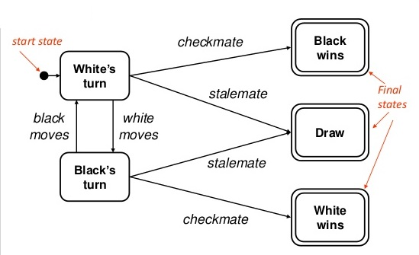

Your task is:

1. Find and write down the minimal set of test cases which cover all transitions and states. Have in mind that it is not possible that the first transaction leads to a final state. You should have at least 1 transaction between states **White’s turn** and **Black’s turn** before you have a transaction to any of the final states.
2. Make a state transition table from the diagram. The column Action is optional.
3. Make 0-switch and 1-switch coverage having in mind the condition in A.

## Problem 2. Telerik Testing Framework

Make functional web tests using Telerik Testing Framework that:

* Navigates to <http://docs.telerik.com/teststudio/>
* Using the tree on the left navigates to “*Testing Framework\ Write Tests in Code\ Advanced Topics\ HTML Popups and Dialogs\Built-In Handlers*”
* Verifies that the correct page is loaded
* Clicks the “HTML Pop-ups” link
* Verifies that the correct page is loaded

Think how to reuse your code.

## Problem 3. Sikuli

Prerequisites: Use Exam.html

Make the following tests using Sikuli with basic framework:

1. From dropdown menu select **"Mercedes-Benz - C"**. Verify that you have selected the correct model.
2. You have a form with checkboxes, some of which are checked by default. Your task is to check only the items containing dots. You are allowed to use 3 images maximum. Make sure that your test will pass if the form content gets changed.

### Terms and Conditions:

During the exam you are allowed to use any teaching materials, lectures, books, existing source code, and other paper or Internet resources.

Direct or indirect communication with anybody in class or outside is forbidden. This includes but does not limit to technical conversations with other students, using mobile phones, chat software (Skype, ICQ, etc.), email, forum posts, etc.